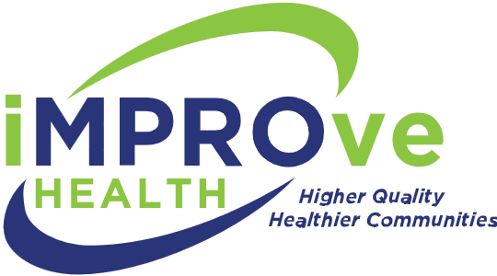 |  | 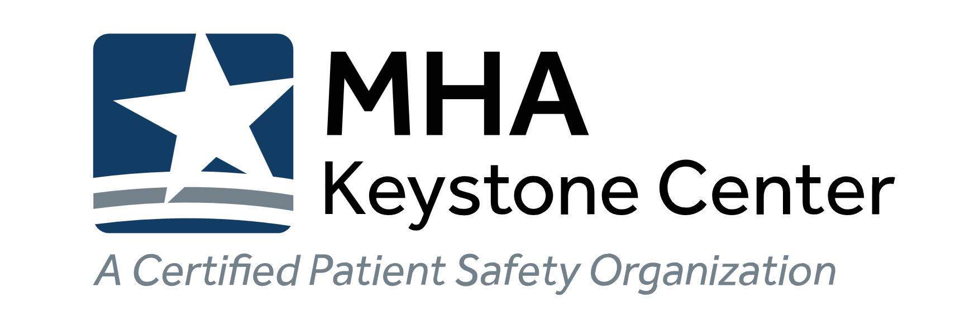

Turn-Key Press Kit
Contents and Instructions
Congratulations on receiving the Governor’s Award of Excellence! You can easily promote your accomplishments to your clients, staff, leadership and the community by using any combination of the pieces in this kit. Download items by visiting https://www.improve.health/presskit
Be sure to go to https://www.improve.health/governorsaward to access your photograph from the award ceremony. A password to access the page will be emailed to award recipients. Reference the Award Recipient list for your award name.
Quotes and language are offered as guidance. You may use quotes verbatim or alter as needed.
External Promotion

- Press Release
Easily insert your organization’s details into the bracketed areas and submit to appropriate media – this can also be used in your external newsletter.
Submit to podcasts, online news platforms, newspaper, television, radio, publications and journals at no cost. You may pay for distribution to media outlets via newswires, i.e., PR Newswire.
Be sure to include your complimentary professional photograph from the ceremony. Including a photograph will increase your chances of free, earned media.
- Governor’s Award of Excellence Recipient Logo
Add this logo to all your materials. It can easily be added to electronic letterhead, website and email signatures. Be sure to share it with all staff if you’d like it in their signature lines.
- Letter/Email to Patients and Clients
The work you did to earn the award was all for your patients and clients, let them know about it! Simply insert your organization’s details into the brackets.
- Oversized Postcard for Patients and Clients
Easily personalize this striking oversized postcard, print it and send it.
- Poster — External Promotion
Use this artwork to print posters. Promote achievements to patients/clients. Place posters in lobbies and waiting areas.
- Talking Points
Quick reference points for the award. This can easily be used for talking to the media, announcements to staff, creating a video and other materials.
- Website Banner and Social Media
Add this graphic to your website or social media feeds to create quick, eye-catching awareness of your accomplishment.
- Window Clings
Use this artwork to print easily-removable window clings and place on doors and glass throughout your organization.
Internal Promotion

- Email to Staff and Internal Newsletter Submission
In some way, everyone worked to earn this award — recognize them! You can use this text in an email to staff and run it in your organization’s internal newsletter. Be sure to include your complimentary professional photograph from the ceremony.
- Poster — Internal Promotion
Recognize the team that worked to earn the award! Use this artwork to print posters. Place posters in break rooms, hallways, meeting rooms.
- Screensaver
Upload this graphic to remind everyone of their achievement.

